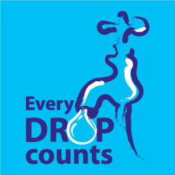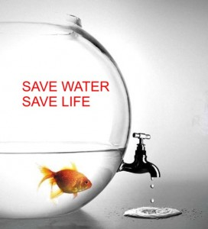

nunezwatersaversgr12.weebly.com

Visit our website to learn how you can help conserve water and how bad pollution really is!

# When most people think of water, they think of oceans with tons of water in them. But the truth is that only a small percentage of our water is drinkable! Although 75% of the Earth is water, only 3% is clean.

## With our growing population, we are polluting more and more of our small water supply and drinking and wasting so much that there won’t be enough to go around. People who live in places like India and Africa have to drink water that we polluted because they don’t have a good cleaning system. 1,600 people die in India *per day* because they have to drink our pollution.

Save Water!